**An incubated co-working space for technology innovation**

**PMBOK / PRINCE 2 BY**

**NIKIWE MDABULA**

**Team Register**

|  |  |
| --- | --- |
| **Member Name** | **Role Description** |
| Nikiwe Mdabula | Leader |
| Thabo Nonkenge | Member |
| Siphokazi Qebelu | Member |

THE CORTEX HUB

|  |  |
| --- | --- |
|  | |
| **TOPIC** | PMBOK/ PRINCE 2 |
| **TIME FRAME** | 1 MONTH |
| CONTENTS | * INTRODUCTION * HISTORY * PROCESSES * APPLICATIONS * BENEFITS * PROS AND CONS * COMPARISOM BETWEEN PRINCE 2 AND PMBOK * DIFFERENCES BETWEEN PRINCE 2 AND PMBOK * WHAT I LIKE ABOUT PRINCE 2 * CONCLUSION * REFERENCES |

**PMBOK (Project Management Body of Knowledge)**

**Introduction**

The Project Management Body of Knowledge (PMBOK®) is an internationally recognized standard (IEEE, ANSI) that deals with the application of knowledge, skills, tools, and techniques to meet project requirements. The PMBOK Guide defines a Project Life Cycle, 5 Process Groups and 9 Knowledge areas of the project management profession.

A project team operates in 9 knowledge areas through a number of basic processes is summarized below:

1. **Integration**: Develop the Project Charter, Scope Statement and Plan. Direct, Manage, Monitor and Control Project Change.
2. **Scope**: Planning, Definition, Work Break-down Structure (WBS) Creation, Verification and Control.
3. **Time**: Definition, Sequencing, Resource and Duration Estimating, Schedule Development and **Schedule** Control.
4. **Cost**: Resource Planning, Cost Estimating, Budgeting and Control.
5. **Quality**: Quality Planning, Quality Assurance and Quality Control.
6. **Human Resources**: HR Planning, Hiring, Developing and Managing Project Team.
7. **Communications**: Communications Planning, Information Distribution, Performance Reporting, Managing Stakeholders.
8. **Risks**: Risk Planning and Identification, Risk Analysis (Qualitative e and Quantitative), Risk Response (Action) Planning and Risk Monitoring and Control.
9. **Procurement:** Acquisition and Contractingg Plan, Sellers Responses and Selection, Contract Administration and Contract Closure.

**Origin of PMBOK. History**

The Project Management Institute (PMI) was founded in 1969, initially to identify common management practices in projects across industries.

* The first edition of the P MBOK was published in 1987. It was the result of workshops initiated in the early 80s by the PMI. In parallel a Code of Ethics was developed. And guidelines for accreditation of training centres and certification of individuals.
* Later, a second version of the PMBOK was published (1996 and 2000), based on comments received from the members. PMBOK was recognized as a standard by the American National Standards Institute (ANSI) in 1998, and later by the Institute of Electrical and Electronics Engineers (IEEE).
* The third version of the PMBOK Guide (tm) was published in 2004, with major improvements in the structure of the document, additions to processes, terms and domains of program and portfolio.

**Usage of PMBOK. Applications**

All kinds of project, programs and portfolio management. Application areas include:

* Management programs (General)
* Departmental projects (Functional)
* Engineering projects (Technical)
* Industry specific processes
* Product development (Marketing)
* Government programs (Public)
* Development programs (International organizations)

**PMBOK Process**

A Project is accomplished through the integration of the project management processes. PMBOK uses a variation of the Deming Cycle for continuous improvement with a 5 -step lifecycle:

[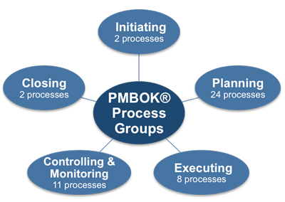](http://www.google.co.za/url?sa=i&rct=j&q=&esrc=s&source=images&cd=&cad=rja&uact=8&ved=0CAcQjRw&url=http://www.free-management-ebooks.com/faqpm/principles-16.htm&ei=1SVgVZKQOcTaU76zgfgF&bvm=bv.93990622,d.ZGU&psig=AFQjCNEyfijgYSOVLUoam2zvmwaQYm4bjg&ust=1432450877792923)

1. Initiating. Main elements:PMI PMBOK Processes
   * Authorize the project
   * Commit the organization to a project or phase
   * Set the overall direction
   * Define top-level project objectives
   * Secure necessary approvals and resources
   * Validate alignment with overall business objectives
   * Assign project manager
   * Integration management
2. Planning. Main elements:
   * Define project scope
   * Refine project objectives
   * Define all required deliverables
   * Create framework for project schedule
   * Provide forum for information sharing for team members and stakeholders
   * Define all required activities
   * Sequence all activities
   * Identify required skills and resources
   * Estimate work effort
   * Risk analysis and avoidance
   * Define and estimate all required costs
   * Obtain project funding approval
   * Communication plan
3. Executing. Main elements:
   * Coordinate the resources, team development
   * Quality assurance
   * Select and approach subcontractors
   * Distribute information
   * Work the plan
4. Monitoring and Controlling. Main elements:
   * Manage team, stakeholders, subcontractors
   * Measuring progress and monitoring performance (overall, scope, schedule, costs, quality)
   * Take corrective actions if and where needed. Issue resolution and escalation
   * Change request management
   * Risk Management (technical, quality, performance, project management, organizational, external)
   * Performance reports. Communications
5. Closing. Main elements:
   * Finalize activities
   * Administrative close out (gather, distribute, archive information to formalize project completion, acceptance/signoff, evaluation, member appraisals, lessons learned)
   * Contract close out (completion of the project contract including resolution of open items and final formal acceptance)

The Project Manager is responsible for the project objectives to deliver the final product that has been defined, within the constraints of project scope, time, cost and required quality.

**Strengths and Benefits of PMBOK**

* PMBOK guide is a framework and de facto standard.
* It is process-oriented.
* It states the knowledge needed to manage the life cycle of any Project, Program and Portfolio through their processes.
* It defines for each process the necessary input, tools, techniques and output (deliverables).
* It defines a body of knowledge on which any industry can build it specific best practices for its application area.

**PRINCE2 (an acronym for Projects IN Controlled Environments)**

Projects in Controlled Environments or PRINCE2 for short has become one of the most popular and widely used project management methodologies around. Used by both the public and private sectors, it has become the de-facto standard for project management in the UK.

PRINCE 2 is a de facto process-based method for effective project management. Used extensively by the UK Government, PRINCE2 is also widely recognized and used in the private sector, both in the UK and internationally. The PRINCE2 method is in the public domain, and offers non-proprietorial best practice guidance on project management.

**Key features of PRINCE2**:

* Focus on business justification
* Defined organization structure for the project management team
* Product-based planning approach
* Emphasis on dividing the project into manageable and controllable stages
* Flexibility that can be applied at a level appropriate to the project

**PRINCE2 History**

* PRINCE was established in 1989 by CCTA (the Central Computer and Telecommunications Agency), since renamed the OGC (the Office of Government Commerce). In June 2010, the Office of Government Commerce Best Practice Management functions moved into the Cabinet Office.
* PRINCE was originally based on PROMPT, a project management method created by Simpact Systems Ltd in 1975, and adopted by CCTA in 1979 as the standard to be used for all Government information system projects.
* When PRINCE was launched in 1989, it effectively superseded PROMPT within Government projects. PRINCE remains in the public domain and copyright is retained by the Crown. PRINCE2 was published in 1996, having been contributed to by a consortium of some 150 European organizations.

**How PRINCE2 Can Benefit You or Your Organisation?**

Using PRINCE2 provides you with greater control of resources, and the ability to manage business and project risk more effectively. This will benefit:

* Individuals seeking leading project management skills and greater employment prospects
* Project managers
* Directors/executives (senior responsible owners) of projects, and
* Organisations.

For individuals, PRINCE2 certification is an invaluable asset to your career as it increases employment prospects and helps you to do your job more effectively.

For organisations, PRINCE2's formal recognition of responsibilities within a project, together with its focus on what a project is to deliver (the why, when and for whom) provides your organisation's projects with:

* A common, consistent approach
* A controlled and organised start, middle and end
* Regular reviews of progress against plan
* Assurance that the project continues to have a business justification

**Why was PRINCE introduced?**

It's true to say that the public sector has hardly covered itself in glory with their ability to deliver projects on time and within budget. PRINCE and subsequently PRINCE2 were introduced to address the common causes of project failure.

**How does PRINCE2 work?**

PRINCE2 is a best practice framework that helps managers deliver projects on time and within budget. It divides projects into clearly defined stages with a start, middle and end. It focuses on the delivery of products rather than carrying out activities. Every project must have a business case and plan that is periodically reviewed to check the project is still viable.

A PRINCE2 project has the following characteristics:

* A finite and defined lifecycle.
* Defined and measurable business products.
* A corresponding set of activities to achieve the business products.
* A defined amount of resources.
* An organisation structure, with defined responsibilities, to manage the project.

**PRINCE 2 PROCESSES**

[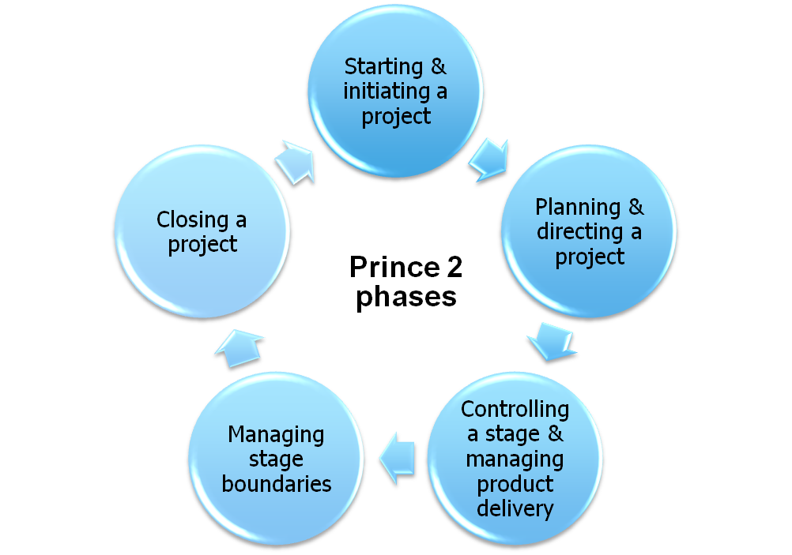](http://www.google.co.za/url?sa=i&rct=j&q=&esrc=s&source=images&cd=&cad=rja&uact=8&ved=0CAcQjRw&url=http://www.siggis.be/en/services/application-development&ei=EjRgVYaZMszV7Qbyz4LICw&bvm=bv.93990622,d.ZGU&psig=AFQjCNHSEu9nrWFz3jC9CPGPQ8Z6pgS-aw&ust=1432454534795683)

**How does PRINCE2 structure a project**?

Core to the methodology is the project board, made up of the customer, user representative and supplier. The project manager reports to this board with regular progress reports, problems and the board decide how the project should proceed.

**The diagram below illustrates the idea:**

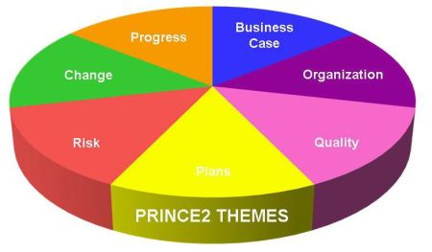

**The Pros and Cons of the Methodology**

One benefit of using this method over others could be said to be the fact that it is product-based and it also divides the project into different stages making it easy to manage. This is sure to help the project team to remain focused and deliver a quality outcome at the end of the day.

The most important of all benefits is that it improves communication between all members of the team and also between the team and other external stakeholders, thereby giving the team more control of the project.

It also gives the stakeholder a chance to have a say when it comes to decision making as they are always kept informed by the issuance of reports at regular intervals.

PRINCE2 also ensures that improvements can be made in the organization. This is because you would be able to identify any flaws that you make in projects and correct, which of course would help you to a great extent in the long run.

The flexibility of PRINCE2 allows these changes to be made run-time. Although there can be some implications and issues to the project schedule when certain changes are done run-time, PRINCE2 offers some of the best practices to minimize the impact.

Your team will also learn to save a lot of time and be more economical when it comes to the use of assets and various other resources, thereby ensuring that you are also able to cut down on costs a great deal.

When it comes to disadvantages, PRNCE2 does not offer the level of flexibility offered by some of the modern project management methodologies. Since project management, especially in software industry, has grown to a different level, PRINCE2 may find difficulties in catering some of the modern project management needs.

**PRINCE2 Positives**

PRINCE2 is a structured approach to project management. It provides a method for managing projects within a clearly defined framework. PRINCE2 describes procedures to coordinate people and activities in a project, how to design and supervise the project, and what to do if the project has to be adjusted if it doesn’t develop as planned. In the method each process is specified with its key inputs and outputs and with specific goals and activities to be carried out, which gives an automatic control of any deviations from the plan.

Divided into manageable stages, the method enables an efficient control of resources. On the basis of close monitoring the project can be carried out in a controlled and organised way. Being a structured method widely recognised and understood PRINCE2 provides a common language for all participants in the project. The various management roles and responsibilities involved in a project are fully described and are adaptable to suit the complexity of the project and skills of the organisation.

**PRINCE2 Negatives**

PRINCE2 is sometimes incorrectly considered inappropriate for very small projects, due to the work required in creating and maintaining documents. However, this may often be because of poor implementation: PRINCE2 is fully scalable.

**What is PRINCE2 exactly and how does it compare to PMBOK?**

PMBOK originated in the US and PRINCE2 was created by the UK government. Many Project Managers (PMs) in the UK have heard of PMBOK and some PMs in North America have heard of PRINCE2, yet most of these PMs do not know exactly what either PRINCE2 or PMBOK are. Many people have assumed that PRINCE2 and PMBOK are alternative approaches to project management - competitors fighting for numbers of trained and accredited PMs. But are they really? Absolutely not.

In fact, they are complementary and can be paired to improve how you manage your projects

**PMBOK (PROJECT MANAGEMANT BODY OF KNOWLEDGE)**

* an encyclopedia of information on all things project management
* the sum of ‘generally accepted’ project management knowledge and principles
* a common lexicon of project management terms

**PRINCE2** = Projects IN a **C**ontrolled **E**nvironment (PRINCE2)

* a process-based project management methodology  based on 7 Principles, 7 Themes, and 7 Processes
* a non-proprietary standard used by the UK Government and supported by the [APM Group](http://www.apmg-international.com/APMG-UK/PRINCE2/PRINCE2Home.asp)
* offers three guides

[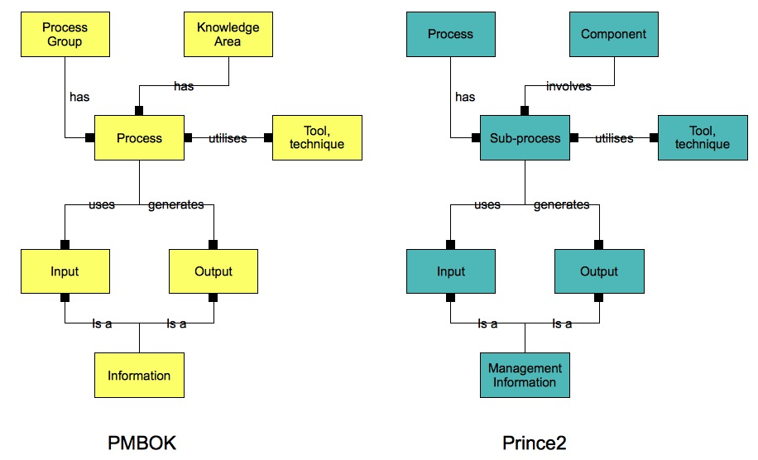](https://www.google.co.za/url?sa=i&rct=j&q=&esrc=s&source=images&cd=&cad=rja&uact=8&ved=0CAcQjRw&url=https://projectleadershipwaterloo.wordpress.com/2011/05/16/project-management-methodologies/&ei=vkVgVcCwIseV7AbXyYGwCg&bvm=bv.93990622,d.ZGU&psig=AFQjCNG_gEakP4QtHkq57mcLBxemwnPAlQ&ust=1432459059127062)

**PRINCE 2 AND PMBOK PROJECT MANAGEMENT EXPERTISE**

[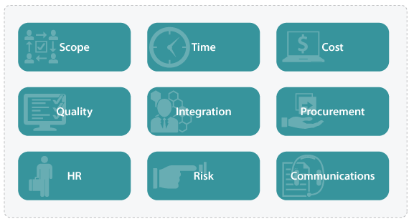](http://www.google.co.za/url?sa=i&rct=j&q=&esrc=s&source=images&cd=&cad=rja&uact=8&ved=0CAcQjRw&url=http://www.dialog.com.au/expertise/project-management/prince2/&ei=JEtgVauCHuvB7AbphILoBA&bvm=bv.93990622,d.ZGU&psig=AFQjCNHaI5xgJ5iuVBwqR4_XcatZUEB6Hg&ust=1432460424656930)

**KEY DIFFERENCE BETWEEN PRINCE 2 AND PMBOK**

|  |  |
| --- | --- |
| PMBOK | PRINCE 2 |
| * Body of knowledge of best practices * Knowledge - oriented * Easier for learning project management skills because it is organised as knowledge areas * In PMBOK the project manager is more cercus and has more decisions * The plan drives the project * Considers project artefacts as deliverables. | * More prescriptive than PMBOK * Process – oriented * Easier to apply without prior project management experience between it prescribed process. * In PRINCE 2 the project manager has less power * Business case drive the project * PRINCE 2 emphasises products as deliverables. |

[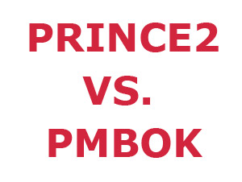](http://www.google.co.za/url?sa=i&rct=j&q=&esrc=s&source=images&cd=&cad=rja&uact=8&ved=0CAcQjRw&url=http://www.prince2training-uk.org/prince2-vs-pmbok/&ei=x0FgVd2XHqKC7gbatoHADQ&bvm=bv.93990622,d.ZGU&psig=AFQjCNGit3tAJ3LuEV3my9m0Py0nYwiYDg&ust=1432458002215801)

**WHAT I LIKE IN PRINCE 2**

I believe that the prince 2 methodology framework might be better suited to design a project management method.

* Prince 2 better explains how roles other than the project manager contribute to the project.
* Prince 2 is better suited to matrix organisation than PMBOK because the role and power of the project manager better reflects the reality of matrix environment.

These components are not as comprehensively defined as the Areas of Knowledge. For example, PRINCE2covers PMBOKTime and Cost Management within its discussion of Plans but only insofar as the development of time and cost information is necessary at the relevant plan level. The following summarizes the PRINCE2components:

**Business Case:** The existence of a viable Business Case (project justification) is the main control condition for a PRINCE2project. The Business Case is verified by the Project Board before a project begins and at every major decision point throughout the project. The project should be stopped if the viability of the Business Case disappears for any reason.

**Organization:** Since the [Project Manager](http://www.corpedgroup.com/consulting/online-skills-assessment.asp) often has to direct staff who report to other management structures, some senior management oversight organization is needed to assure that those diverse resources are committed to the project. In addition, viability decisions need to make by management with an investment in the project, and an accountability for delivering it through the Project Manager. In PRINCE2this oversight is the Project Board.

**Plans:** Plans are the backbone of the management information system required for any project, and require the approval and commitment of the appropriate levels of the project organization. The "Plans" component emphasizes the core concepts of planning; the major steps are highlighted in the process model in Planning.

**Controls:** Control is about decision making: its purpose is to ensure that the project (a) is generating the required products which meet defined Acceptance Criteria; (b) is being carried out to schedule and in accordance with its resource and cost plans; (c) remains viable against its Business Case, and (d) with acceptable level of risk.

**Management of Risk:** As project work is inherently less predictable than non-project work, [management of the risks](http://www.corpedgroup.com/courses/scedesc.asp?CID=16456) is an essential part of project management. To contain risks during the project, they must be managed in a disciplined manner, through risk analysis and risk management (as in the PMBOK®).

**Quality in a Project Environment:** Quality management ensures that the quality expected by the customer is achieved through a quality system (similar to the PMBOK). Quality requirements of the project's deliverables ("products") are based in Product Descriptions, created by the Project Manager and approved by the Project Board.

**Change Control:** Controlling scope change means assessing the impact of potential changes, their importance, cost, impact on the Business Case, and a decision by management on whether or not to include them.

**Configuration Management:** Configuration Management gives the project management team control over the project's assets (the products that it develops), and is vital to any quality system. It provides mechanisms for tracking and controlling the project's deliverables, and a system for tracking project Issues.

[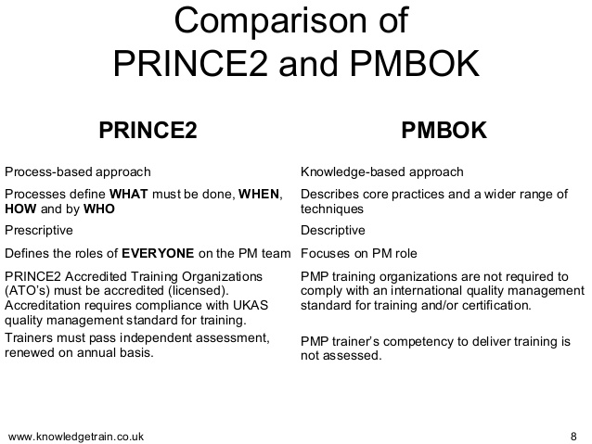](http://www.google.co.za/url?sa=i&rct=j&q=&esrc=s&source=images&cd=&cad=rja&uact=8&ved=0CAcQjRw&url=http://www.slideshare.net/simonbuehring/prince2-and-pmbok&ei=mkFgVZr_BYOy7Qas2YCIAg&bvm=bv.93990622,d.ZGU&psig=AFQjCNGit3tAJ3LuEV3my9m0Py0nYwiYDg&ust=1432458002215801)

**PRINCE S AND PMBOK PROCESSES**

[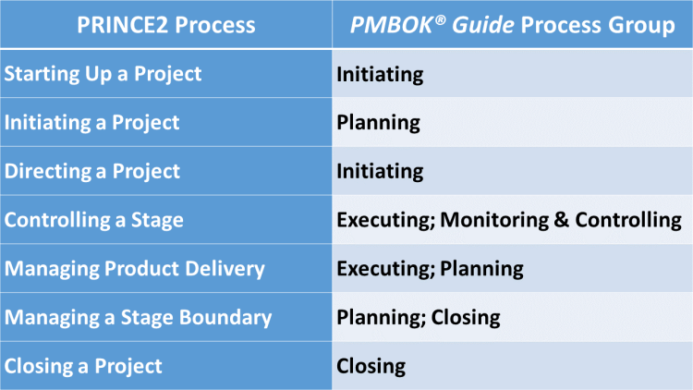](http://www.google.co.za/url?sa=i&rct=j&q=&esrc=s&source=images&cd=&cad=rja&uact=8&ved=0CAcQjRw&url=http://www.knowledgetrain.co.uk/comparing-prince2-with-the-pmbok-guide.php&ei=BUhgVazgJ4i67gbQiYLYAw&bvm=bv.93990622,d.ZGU&psig=AFQjCNHgROxF3aIHXKgKtJQ2fjOt6Wrs0Q&ust=1432459639748293)

**Conclusion**

It should be kept in mind that PRINCE2 is a very complex method and cannot be carried out without special training. Failure to understand precisely how it works could lead to a lot of problems and difficulties whilst carrying out the project.

PRINCE2 guidelines can be selectively applied to certain projects that do not last long. This makes the method even more flexible and thereby more appealing to dynamic organizations and projects.

**REFERENCES**

-PROJECTSMART.CO.UK

-WWW.GOOGLE.CO.ZA

-WHATLS.COM

-TUTORIALPOINT

-WWW.KNOWLEDGETRAIN.CO.UK